28 April 2021

Response to reviewers **Schilling et al.**

Thank you for the opportunity to respond to the reviews. This response letter is formatted to give each editor/reviewer comment (numbered) followed by a response to each comment in blue and quotes from the main text in italics.

Reviewer 1:

**Comment #1:** Zooplankton play important roles in marine ecosystem. The observation of biological oceanography is far behind the physical and chemical oceanography due to the limitation of the observing technique of biological variables. The authors presented the high resolution vertically resolved profiles of the zooplankton biomass and size structure across four transects over a continental shelf, and discussed the relationship between zooplankton and relevant physical processes, which provided important information on the zooplankton characteristics on the eastern continental shelf of Australia and insights of the zooplankton pattern over the continental shelf. However, the single cruise, the lack of the simultaneous chemical oceanographic observation, the lack of zooplankton taxa and statistical analysis make the mechanism more descriptive.

**Response:** We appreciate the reviewer highlighting the importance of our study in describing the zooplankton characteristics over the eastern continental shelf of Australia and acknowledge that our study is largely descriptive. This descriptive nature is due to the sampling design of 4 transects which may bias any statistical analyses due to autocorrelation. Rather than calculate spurious statistics we prefer to present the observed patterns. Remarkably, the cross-shelf patterns we observe seems to reflect other coasts around the world (Figure 7).

We have now incorporated more chemical oceanographic observations which we think provide more certainty in some of our findings and help to place the observations from our study in a broader seasonal context. The newly included chemical observations all provided in the supplementary material include cross shelf transects of Salinity, Nitrate, Phosphate, Oxygen and Chlorophyll *a* all overlaid with temperature contours for comparison (Supplemental Figures X, Y, Z).

**Comment #2:** 1) Zooplankton biomass is highest inshore, which declines with increasing distance from shore and with increasing depth in the water column. This is true for most continental shelves or transects from the coast to the open ocean according to the published work. One purpose is to relate the observations to previous research to propose a general concept of zooplankton size-structure on continental shelves globally. The continental shelf is different globally, if there is a globally general pattern, does that mean that the influence of the western boundary current is not the key process affecting the zooplankton community structure? Maybe different inherent mechanisms can be classified based on different locations, not necessarily one general concept globally.

**Response: Iain/Mark – temperature patterns**

The common fundamental process that unites all studies is the nutrient enrichment that occurs in all near-coastal waters, due to many different upwelling processes (coastal winds, reverse Ekman, or topographic effects) and estuarine processes and run-off from land. Therefore, western boundary currents do have a major influence on coastal enrichment, but not the only cause. This drives the ubiquitous “green-ribbon” (Lucas et al. 2011) in chlorophyll-a observed along most coasts world-wide, and our study together with related work establishes a general pattern in zooplankton size and abundance.

**Comment #3:** 2) According to the previous research, the change of the vertical patterns of the zooplankton size related to the depth of the target area. For example, the zooplankton became larger with increasing depth (>100 m) in some areas. The depth of this research is about 100 meters or less, I think the authors should clarify that in the range of 0-100m, the size become smaller with the increasing depth.

**Response:** We have now clarified this point in the abstract, results and discussion.

**Comment #4:** 3) The survey was conducted in one week. Considering that one purpose of this work is to find a general concept, are there any evidences that can prove that the seasonal change is not dramatic in this area?

**Response: Iain Respond with we are only really interested in spring**

In fact there are substantial seasonal changes in the strength of the East Australian Current (faster in spring and summer, Fig. 6), and therefore in the frequency of upwelling (strongest in spring, Vincent’s paper with Moninya). We selected spring when many commercial fish spawn, but as shown in Fig. 7 these patterns seem to be ubiquitous regardless of season or location. It would be interesting to compare these changes in other seasons in relation to seasonal cross-shelf distributions of chlorophyll. We expect the patterns in other seasons to be similar (i.e. in proportion to the cross-shelf chlorophyll gradient), and interestingly this effect is evident in our most southern transect off Diamond Head (i.e. less horizontal gradients). We have clarified the effect of seasonality in the Conclusion section (Line reference).

**Comment #5:** 4) The 21 °C isotherm is considered to be the dividing line for the change of zooplankton community characteristics. However, it seems not that clear for either biomass or particle size spectrum from the figures. Temperature, prey, depth, stability of the water mass, are all environmental factors that may affect zooplankton. It'll be ideal to conduct statistical analysis to discern the most critical factors that affect the size and biomass of zooplankton in the West Boundary Current area.

**Response:** We used the 21C isotherm out of convenience for our written description. As the correctly reviewer pointed out, our study is in the spring and therefore at other locations and seasons we would find a different isotherm. Due to our study design of 4 individual transects, the data are autocorrelated (i.e. no true replicates) so we were unable to run any statistical tests with confidence. As both reviewers have identified the 21C isotherm as not a very distinct boundary we have reduced our focus on this as a potential dividing line, but merely use it to locate the attention of the reader.

**Comment #6:** 5) Due to the limitation of OPC, there is no taxa composition of zooplankton. In addition to fish mentioned in the article, predation among zooplankton is also an important factor that may cause the change of zooplankton size spectrum. That means the dominant zooplankton species or taxa are important for the size spectrum. Can you provide the background information of the zooplankton composition in this area?

**Response:** Information on zooplankton composition in this study area is limited and there are no zooplankton composition samples matching the spatial and temporal resolution of the study. To overcome data deficiency, this we used the Continuous Plankton Recorder data from the spatial region of our study but from different times (2009 – 2018) to show the monthly averaged zooplankton composition. Assuming 2004 was of typical zooplankton composition this shows that in September almost 80% of zooplankton individuals are copepods and with only small proportions of other taxa. This composition is relatively stable in the surrounding month (August-October) and we are confident this represents the 2004 community sampled in our paper.

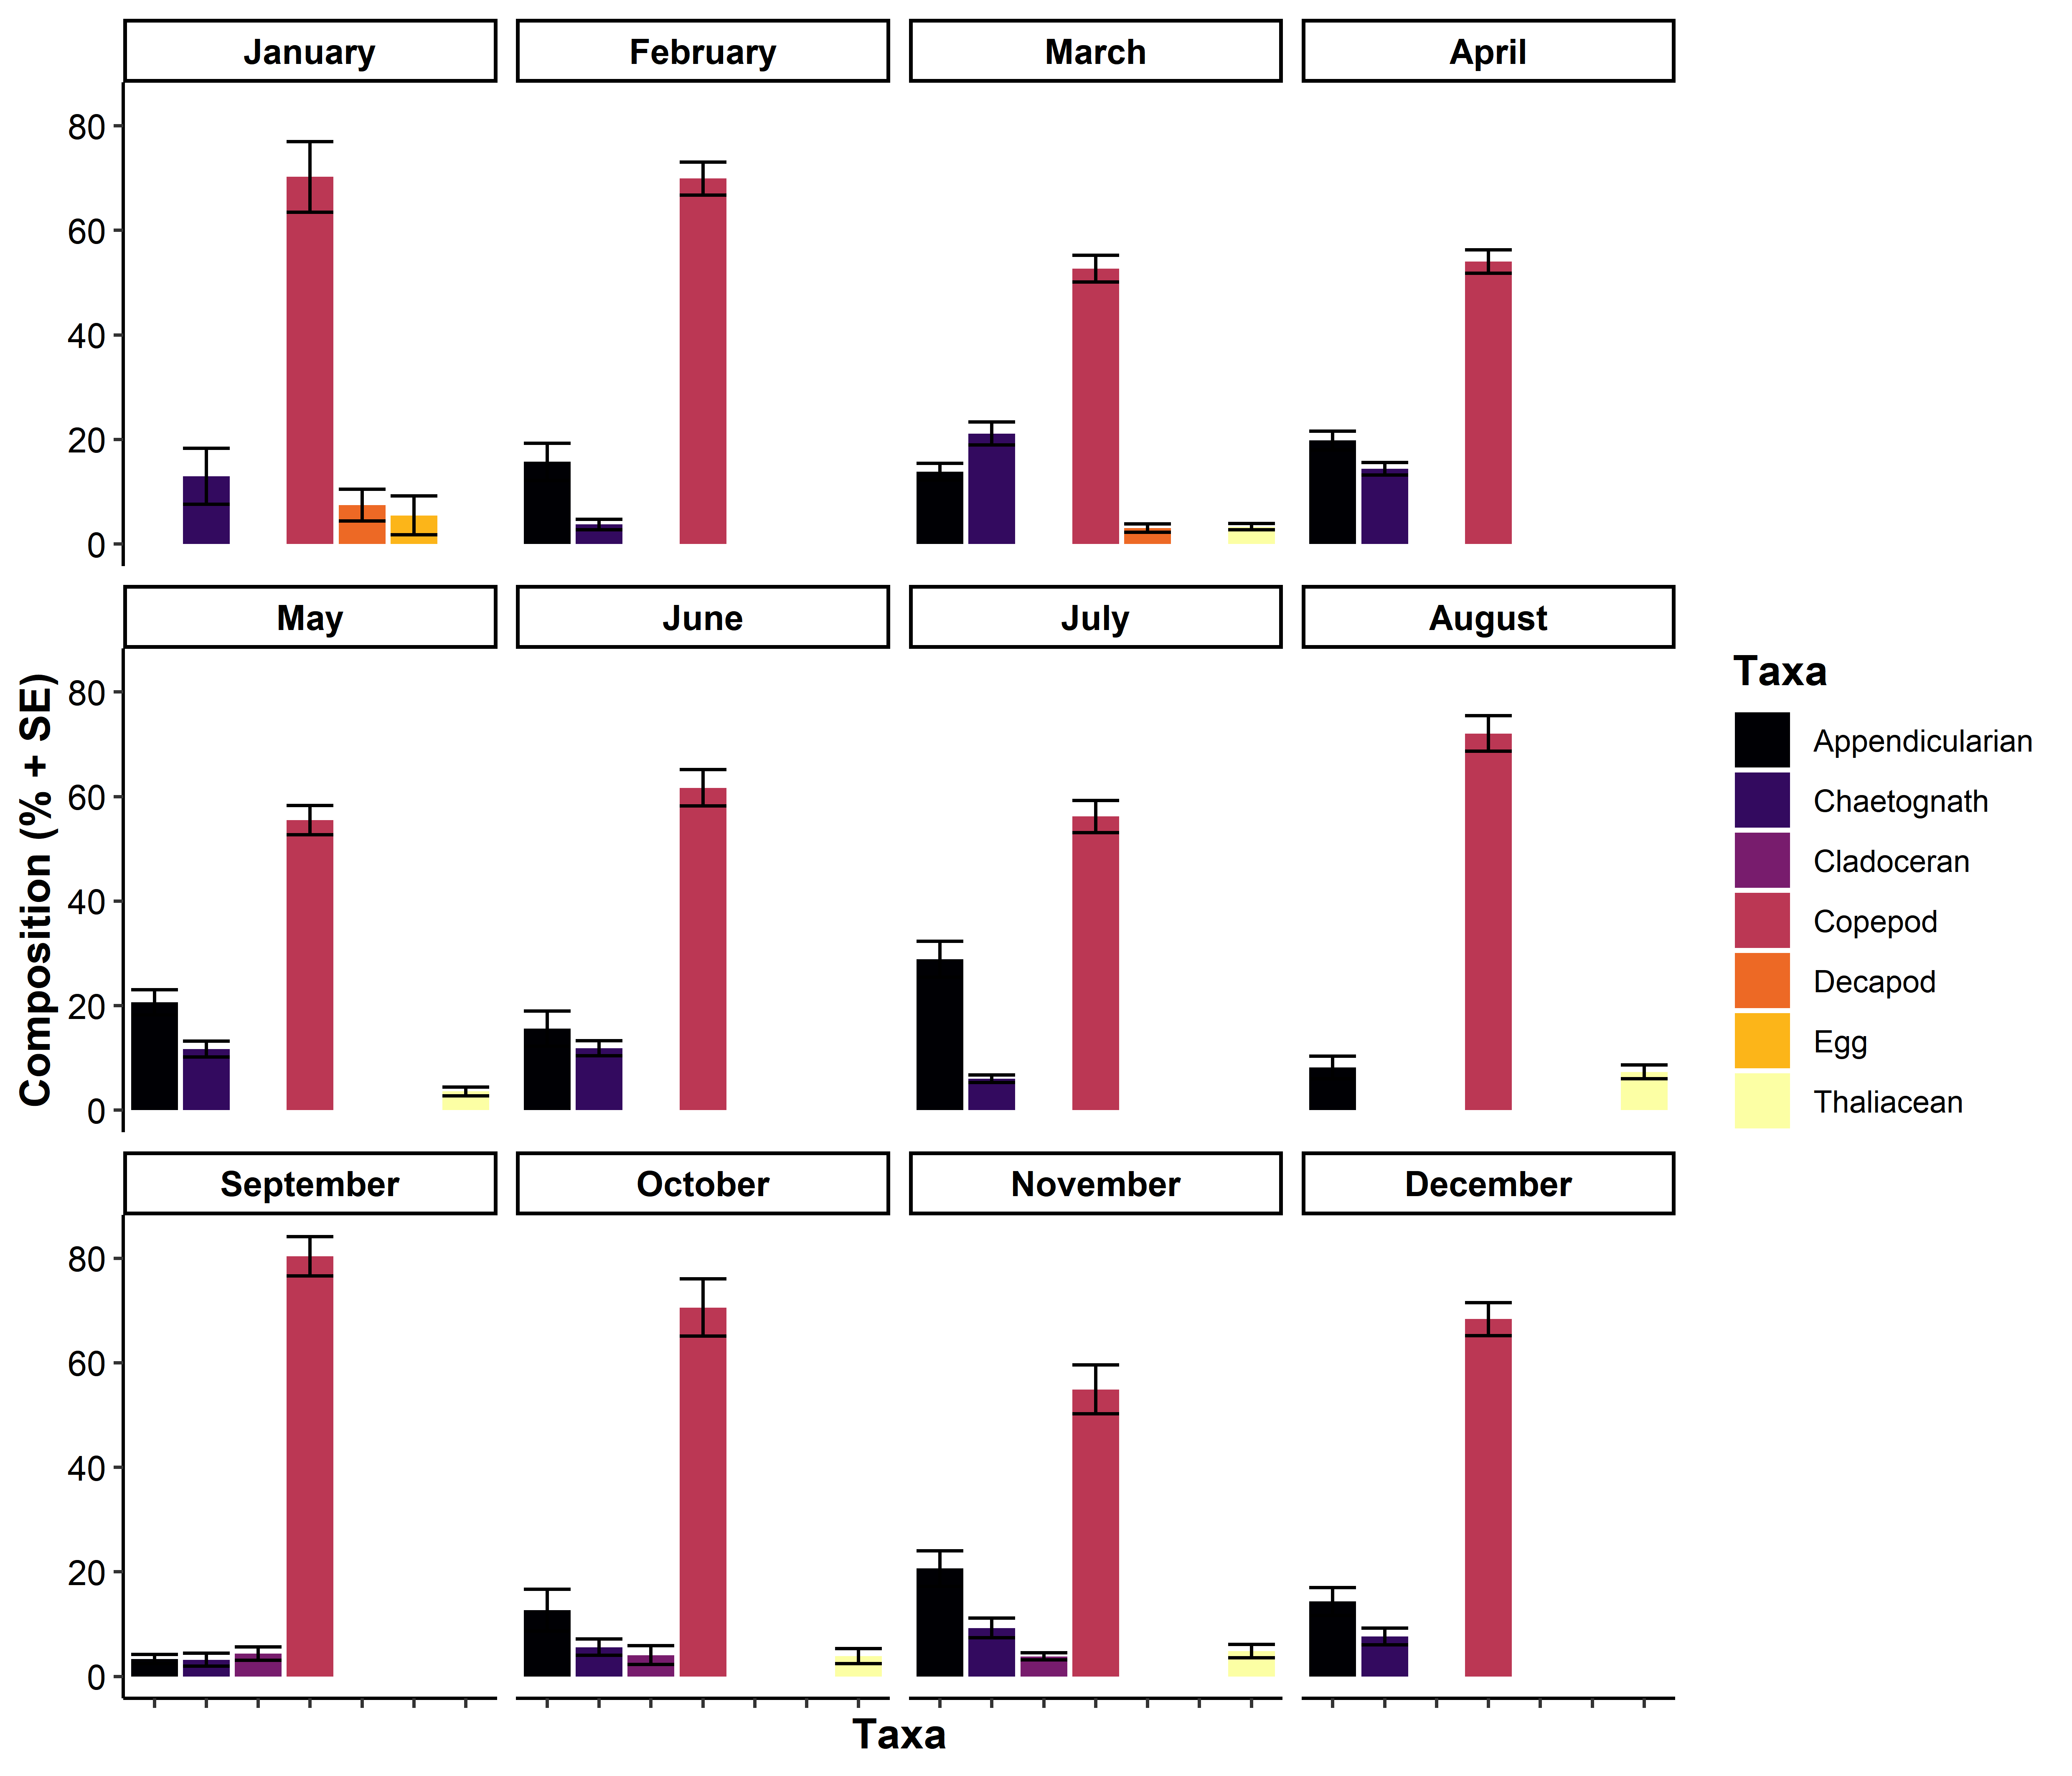

**Comment #7:** 6) Please check the minor problems, such as, P2L33, resulting in "zooplankton ecosystems", usually we don't say zooplankton ecosystems.

**Response:** This has been changed to “particulate communities”. Several other minor issues have been resolved with full details provided in the following comments.

**Comment #7:** P7L146, "a research voyage on the on the RV Southern", delete "on the", etc. Please check other parts of the manuscript.

**Response:** The repeated “on the” has been deleted.

**Comment #8:** 7) P31L531-533, "Within the cross-shelf patterns of zooplankton, biomass and mean size also tend to decline with depth in the water column, possibly as a response to light availability (Aarflot et al., 2019)." Light is the limiting factor of phytoplankton, don't understand why the light availability could affect zooplankton.

**Response:** This section has been deleted.

Reviewer 2:

**Comment #9:** This study presents an interesting dataset of spatial patterns of zooplankton in pelagic ecosystems associated with the East Australian Current. Study motivation and sampling design seem to be proper and interesting enough. However, overall data analyses and what has been done with results constitutes basic research. In general the study could be much improved and strengthened in itself.

**Response:** We acknowledge that our research may be considered “basic research” as this research has not yet been conducted in the East Australian Current region, and in general cross-shelf studies are rare in the literature, particularly the southern hemisphere. By including 14 international studies a general pattern emerges at the crucial interface of oceans and society. This is also the first paper to present depth resolved transects of zooplankton size-structure across a continental shelf anywhere in the world. For further details on how the study has been improved (see other comments on Lines …?).

**Comment #10:** Below I point out a few general comments, while more specific are included in the pdf.

**Response:** Thank you for the comments, we have responded below to all the general and specific comments.

**Comment #11:** - The title says 'zooplankton' but in truth you are analyzing particulates (plankton and detritus), please focus particulates or change the title.

**Response:** Thank you; we have clarified this in the Methods and Discussion (Line reference) and have altered the title. We have kept the word “zooplankton” in the title as do most of the papers that we cite in Fig. 7, otherwise we may lose readership. The title has been changed to “Vertically resolved zooplankton size-structure across a continental shelf under the influence of a western boundary current”

**Comment #12:** - The manuscript requires greater supporting data to justify the claims made.

**Response:** We respond below to the specific areas where the reviewers suggests additional data are needed.

**Comment #13:** - The manuscript requires restructuring to improve the flow.

**Response:** In line with the reviewer suggestions (detailed below) the manuscript has been restructured. For full details see later responses.

Reviewer 2 comments from annotated pdf

**Comment #14:** Line 45: Introduction: Summary

* Please restructure to improve flow (physics, nutrients, chl a and particulates/zooplankton)
* - Please include how top down processes could influence particulate size structure

**Response: IAIN please check** We thank you for these suggestions. We were concerned if we started off with a physics to ecology structure, the reader would not find zooplankton until the 3rd paragraph. Our paper is about zooplankton size-structure, in a physical-nutrient-chlorophyll context rather than about coastal oceanography. With respect, we wish this paper benefits more from the present structure which highlights the biological and ecological importance of firstly continental shelves followed by zooplankton. We have included some additional information about how top-down processes could influence particulate size structure.

The new text is:  
“Top-down pressure from larger predators can also increase the steepness of the size spectrum as increase the mortality rate of the zooplankton, thereby decreasing the efficiency of energy transfer along the spectrum (Moore and Suthers, 2006; Rossberg *et al.*, 2019).”

**Comment #15:** Line 49: High chlorophyll a concentrations doesn't always translate to high primary productivity. High rates of primary productivity increase ecosystem productivity...

**Response:** This line has been rephrased to read “These fisheries are supported by high primary productivity (Bakun and Weeks, 2008; Mackinson *et al.*, 2009), often enhanced by coastal processes including upwelling, boundary currents and eddies (D’Croz and O’Dea, 2007; Patti *et al.*, 2008).”

**Comment #16:** Line 50: References

**Response:** References have been added, see above comment.

**Comment #17:** Line 52: Requires references

**Response:** Reference add, this line now reads: “The high chlorophyll *a* levels often observed on the continental shelf, particularly the inner shelf (Lucas *et al.*, 2011a, 2011b) are a key driver of zooplankton communities which are a key resource for fisheries (Mitra *et al.*, 2014).”

**Comment #18:** Line 58: Insight into what?

**Response:** This sentence has been changed to: “the size frequency distribution of a community can provide valuable insight into the trophic dynamics of a community (Blanchard *et al.*, 2017)”

**Comment #19:** Line 64: delete “all”

**Response:** deleted.

**Comment #20:** Line 66: and predation

**Response:** Predation is mentioned at the beginning of this sentence. It reads: “The size spectrum implicitly reﬂects the outcome of ecological processes including predation, the growth of individuals through different size classes, and the repopulation of smaller size classes through reproduction (Sprules and Barth, 2015; Andersen *et al.*, 2016; Blanchard *et al.*, 2017)”

**Comment #21:** Line 68: Here you identity environmental variables that are important to zooplankton size structure. Need to follow through and present this information in this study.

**Response:** As requested we now present information on environmental variables in the current study see sections XXXX.

**Comment #22:** Line 69: Are there any other variables that have been found to explain variation in particle size-spectra?

**Response:** Size spectra are essentially a visualisation of the community response to any environmental factors, integrating many ecological processes as we discussed in the above sentences. We do not think it is worthwhile discussing individual instances of environmental variables being linked to size spectrum and would rather discuss the interpretation of the size spectra and how these may relate to environmental variables.

This section now reads: “While there is variability in interpretations of size spectra depending on the size of particles in the spectrum due to sampling efficiency and natural ‘dome shapes’ in some communities (Marcolin *et al.*, 2013; Rossberg *et al.*, 2019), within the mesozooplankton size range (≈0.2 – 3mm), the elevation of the spectrum reflects the environmental effects which overall primary production and biomass of a community (Moore and Suthers, 2006; Zhou, 2006). Higher primary production and biomass tends to result in a higher elevation (or intercept) with such impacts demonstrated with nutrient input in both estuarine and pelagic ecosystems (Moore and Suthers, 2006; Baird *et al.*, 2008). Steeper slopes in the size-spectrum represent inefficient energy transfer between trophic levels which can occur under both oligotrophic conditions as nutrients become scarce and eutrophic conditions as many bloom taxa are relatively large yet unpalatable which increases the chances of mass sinking of ungrazed blooms leading to reduced efficiency of energy transfer (Atkinson *et al.*, 2020). Top-down pressure from larger predators can also increase the steepness of the size spectrum as increase the mortality rate of the zooplankton, thereby decreasing the efficiency of energy transfer along the spectrum (Moore and Suthers, 2006; Rossberg *et al.*, 2019).”

**Comment #23:** Line 69: Should also consider how slope values are related to the size of range of particles studied (Marcolin et al 2013).

**Response:** This is a good point, we have made clearer we are referring to the mesozooplankton size range. This section now reads: “While there is variability in interpretations of size spectra depending on the size of particles in the spectrum due to sampling efficiency and natural ‘dome shapes’ in some communities (Marcolin *et al.*, 2013; Rossberg *et al.*, 2019), within the mesozooplankton size range (≈0.2 – 3mm), the elevation of the spectrum reflects the environmental effects which overall primary production and biomass of a community (Moore and Suthers, 2006; Zhou, 2006).”

**Comment #24:** Line 80: Include biophysical processes that influenced observations.

**Response:** This information has now been included. This section now reads: “This is similar to the northeast Atlantic where high zooplankton biomasses and steeper zooplankton size spectrum slopes were found in some but not all inshore regions, most often in the lower salinity, higher chlorophyll *a* coastal water, indicating potential effects of freshwater discharge (Sourisseau and Carlotti, 2006; Irigoien *et al.*, 2009; Vandromme *et al.*, 2014).”

**Comment #25:** Line 82: Why is this important? Identify the need for cross-shelf vertically resolved observations of particulates.

**Response:** This line has been rephrased to highlight the need for cross-shelf vertically resolved observations. The line now reads: “Fewer studies have examined the vertical patterns of zooplankton on continental shelves and this remains a key knowledge gap despite widespread recognition of variation in vertical distributions of zooplankton often attributed to diel vertical migration (Lampert, 1989), and the 3-dimensional influences of continental shelf oceanography (Schaeffer *et al.*, 2013).”

**Comment #26:** Line 84: What is it about the thermocline influences the distribution of particles.

**Response:** This has been reworded, the thermocline was not attributed to any differences in the original paper and was merely used by the original authors to highlight difference water masses.

The new line is: “During late summer, in the northwest Atlantic, the vertical zooplankton distribution was strongly influenced by water mass with distinct zooplankton communities in the observed warmer and colder water masses (Turner and Dagg, 1983).”

**Comment #27:** Line 87: Contents of this paragraph does not lead to this concluding sentence. There is a number of studies that document the effects that oceanography have on zooplankton/particulate communities.

**Response:** This sentence has been rewritten to better reflect the paragraph. It now reads:” As observations of vertical patterns in zooplankton communities on continental shelves remain uncertain in many regions of the world, it is important to demonstrate how boundary currents influence the zooplankton community in shallow coastal waters.”

**Comment #28:** Line 90: The following two paragraphs should come earlier on as they are the primary mechanisms (bottom up drivers) of shelf ecosystem productivity. Add context of:

- physical properties (flooding/upwelling/downwelling/ekman/fronts/uplift/temp/sal/ect)

- nutrients

- aggregation

**Response: Iain similar to comment #4**

**Comment #29:** Line 98: Need to present this supporting information.

**Response:** This is now supported by references to Schaeffer et al (2013), Everett et al (2014) and Kobari et al (2018).

**Comment #30:** Line 103: rephrase paragraph - along shelf flows are the primary mechanisms responsible for cross shelf flow dynamics.

**Response:**

**Comment #31:** Line 128 (Methods): Restructure to describe:

* context of the voyage in relation to seasonal variation in oceanography
* Characterise the seasonal variation in EAC dynamics in area of interest (SSH, SST, velocity, chl a) (Is there any data from IMOS moorings that be used w sat data to do this ?)
* Observed vertically resolved cross shelf plots of temperature, salinity, nutrients, chl a/fluorescence, particulates/zooplankton
* Actual zooplankton samples for community composition information would help verify cross shelf plots (are the RMT samples available)?

**Response: AMANDINE – Please add a paragraph about the EAC seasonality.**

**Cross shelf plots from the study will be in supplementary**

**RMT sample not available.**

**Comment #32:** Line 153 (Figure 1): Need to add legend for velocity strength, also include SSH and Chl a plot here.

**Response: AMANDINE**

**Comment #33:** Line 172 (Table 1): Add a day night field and add diel timing of transects to discussion

**Response:**

**Comment #34:** Line 210: Seasonal variation and cross shelf plots of chlorophyll required in this study

**Response:** Cross shelf plots of chlorophyll *a* are now included in the supplementary material. These plots show minimal changes in chlorophyll across the transects with all transects showing between 1 and 1.5 MG M3 with slight decreases with depth.

Seasonal variation in surface Chlorophyll in this region was extensively investigated in Everett et al (2014) based upon satellite data and it shows that the chlorophyll values observed in our study are typical of the region (within 1 SD of the geometric mean Chlorophyll values). Chlorophyll does typically have a spring bloom in but in the latitudinal region in the current study the mean chlorophyll in spring is typically lower than in winter and the spring is more of a moderate bloom (typically 27 -79 % increase on the annual average). The major spring bloom and seasonality patterns occurs to the south of our study (south of 32°S). Some of this information has now been highlighted better in our manuscript.

For the reviewer we are here providing Figure 4 from Everett et al, showing the long term time series of chlorophyl in this region. Showing that spring (September) 2004 is largely typical.

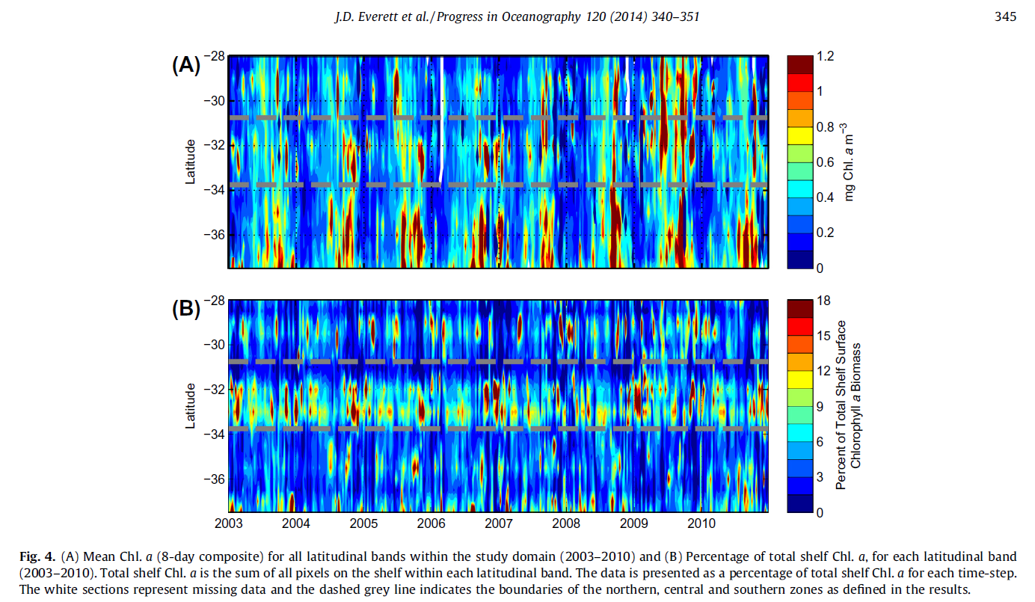

**Comment #35:** Line 215: I'd prefer OPC observations referred to as particulates and in-situ observations of zooplankton (RMT net samples) used to verify OPC observations. Is this possible?

**Response:** The zooplankton samples collected in this voyage have not been inspected for taxonomic composition but some samples were independently analysed with a lab based OPC with the resulting biomass and size spectrum estimates comparable (Mullaney et al 2014).

Previous plankton sampling in the region in which samples were inspected onboard the voyages has shown that inorganic particulate matter is extremely rare (<1%) and almost all collected “particles” consist of whole or fragmented zooplankton with it being likely that significant fragmentation of zooplankton is occurring in the net during the collection process. This fragmentation problem is not relevant for the towed OPC samples and can be seen as an advantage. We prefer to refer to the particles as zooplankton as we are confident >95% of particles from the OPC are in act zooplankton and if not they would be part of the planktonic ecosystem comprising of marine snow which is an essential part of the carbon cycle.

Previous work in this region (including this OPC dataset) has shown that zooplankton biomass modelled off the OPC data correlates significantly with biomass derived from the CPR despite the methodology differences. This lends additional support the argument that the majoriy of ‘particles’ measured are in fact zooplankton.

The following extract is from White (2018):

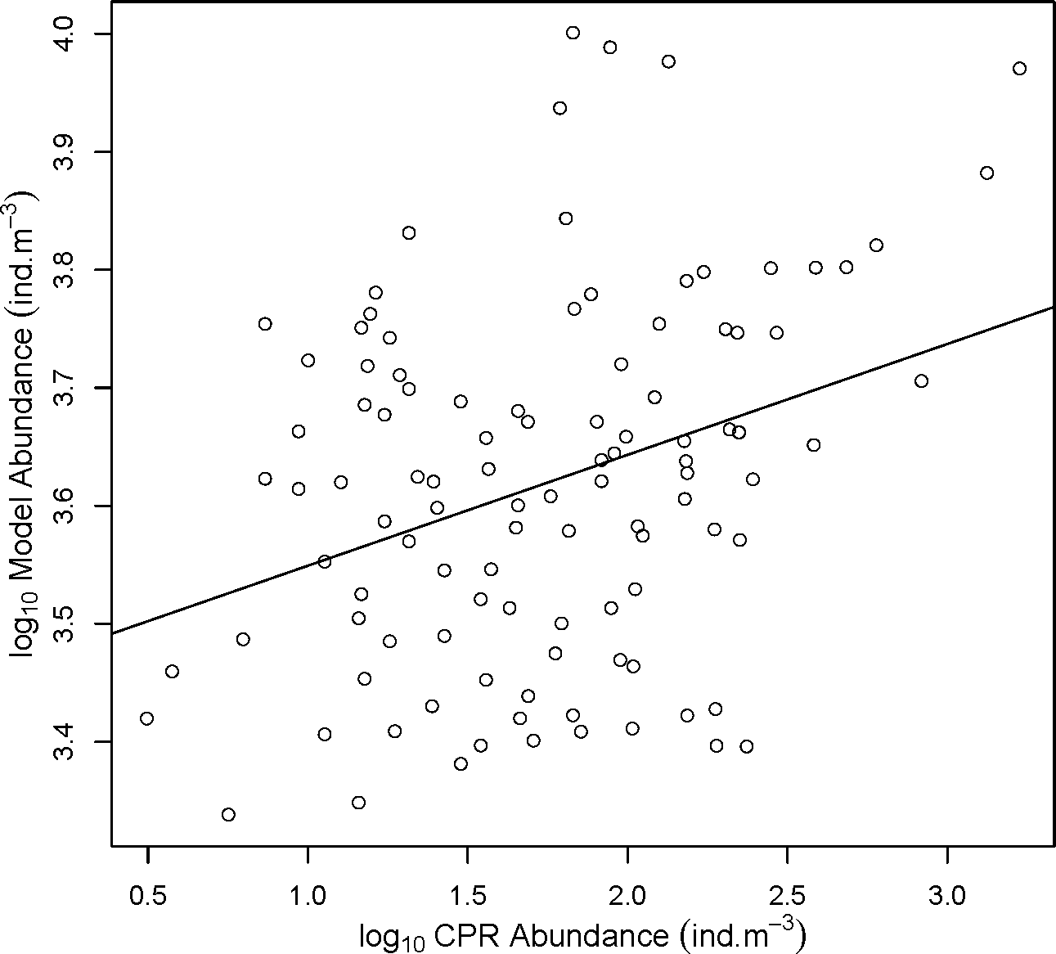

**Figure 3.10 Scatterplot of CPR vs modelled abundance (ind-m-3). Log10Model Abundance =**

**3.455 + 0.09395(log10CPR Abundance)**

A linear regression comparing the abundance model output values to corresponding date and coordinate values of abundance as recorded by CPR showed a significant positive correlation (r2 =0.11, p <0.001) (Table 3.3, Fig. 3.10) with a Pearson’s correlation coefficient of 0.34. CPR abundance data was recorded in the years 2009, 2010, 2012, 2014, 2015 and 2016.

**Table 3.3: Linear Model of log10Abundance measured by the Continuous Plankton Recorder (CPR) compared to log10Abundance as predicted by the model using the date and coordinates of satellite temperature, chlorophyll-*a*, sea level anomaly and bathymetry.**

|  |  |  |  |  |  |
| --- | --- | --- | --- | --- | --- |
|  | **Estimate** | **St. Error** | **t-value** | **p-value** | **r2** |
| **MdlAbund ~Log10CPRAbundance** | | | | | |
| (Intercept) | 3.455 | 0.0470 | 73.49 | <0.001 | 0.11 |
| **Log10CPRAbund** | -0.09395 | 0.0259 | 3.633 | <0.001 |  |

An assessment of the linear model against in-situ Continuous Plankton Recorder data (CPR) showed a positive trend, indicating general agreement between the model and observed data. The weak correlation (r=0.34) may be attributed to the sampling differences between instruments. In particular, the CPR is known to under sample zooplankton abundance, particularly at the larger sizes, sizes smaller than 270 µm (the CPR mesh size (Batten et al. 2003)) and of delicate zooplankton (Owens et al. 2013). The small opening aperture of the CPR reduces catchability of zooplankton as they avoid the CPR (Batten et al. 2003). However, the CPR does capture seasonal and long-term zooplankton trends. In addition, there are temporal discrepancies between the data sources, as the model outputs are based on a seasonal average of the satellite data, whereas the CPR data point is based on the observation of that location at the given date and time. The positive relationship between model and observations is a good outcome and indicates that the broad patterns described here are likely accurate. Further ground truthing could be undertaken to improve the accuracy and calibration of the model outputs, and also used to compare differences between CPR and OPC sampling results.

Mullaney, T.J., Gillanders, B.M., Heagney, E.C. and Suthers, I.M. (2014), Entrainment and advection of larval sardine, *Sardinops sagax,* by the East Australian Current and retention in the western Tasman Front. *Fish. Oceanogr.*, 23: 554-567. <https://doi.org/10.1111/fog.12089>

White (2018) The spatial distribution of zooplankton production in the western Tasman Sea: A size-spectra approach. Masters Thesis (UNSW Australia) http://handle.unsw.edu.au/1959.4/60494

**Comment #36:** Line 224: Biovolume is commonly used in the literature, useful for comparisons and to be consistent. Abundance would be a useful metric to include as well for ecological and global comparison purposes.

**Response:**

**Comment #37:** Line 236: Common practice in literature is to refer to as biovolume.

**Response:**

**Comment #38:** Line 245: Many of these studies describe results in context of environmental and ecological covariates. Please include some way to characterise environmental and ecological context of studies.

**Response:**

**Comment #39:** Line 261: As suggested in the methods sections please restructure to describe:

* Seasonal variation in EAC dynamics (distance from shore, velocity, SSH, SST, chl a)
* Observations of vertically resolved cross shelf plots of temperature, salinity, nutrients, chl a/fluorescence, particulates/zooplankton
* In-situ Zooplankton samples for community composition information would help verify cross shelf plots (RMT)?

**Response:**

**Comment #40:** Line 266: rephrase/remove

**Response:**

**Comment #41:** Line 276: Report EAC centered at xx km offshore above the xxx m depth contour. In the discussion cover how the center of EAC was located x distance from shore / above x depth contour. And how its proximity to coast the depth of water it flowed in influenced uplift?

**Response:**

**Comment #42:** Line 279: Include data from along and cross shelf flow to make this point.

**Response:**

**Comment #43:** Line 285: Data does not support the strength of this statement.

**Response:**

**Comment #44:** Line 291: This paragraph would benefit from consideration of cross shelf patterns in temperature, salinity, nutrients, chl a/ fluorescence

**Response:**

**Comment #45:** Line 295 (Figure 2): Describe the direction of flow +- represents in the caption.

**Response:**

**Comment #46:** Line 319: Rephrase

**Response:**

**Comment #47:** Line 322: Report EAC centered at xx km offshore above the xxx m depth contour. In the discussion cover how the center of EAC was located x distance from shore / above x depth contour at each station. And how its proximity to coast / depth of water it flowed over influenced uplift.

**Response:**

**Comment #48:** Line 323: Include data on along and cross shelf flow to support this point.

**Response:**

**Comment #49:** Line 324: This paragraph would benefit from the inclusion of cross shelf patterns in temperature, salinity, nutrients, chl a/ fluorescence

**Response:**

**Comment #50:** Line 327: Size structure of particulates, community referes to species or functional groups. Data does not support this statement

**Response:**

**Comment #51:** Line 331: Results are not as clear-cut as reported

**Response:**

**Comment #52:** Line 334: Abundance data would be useful

**Response:**

**Comment #53:** Line 337: Include numbers of along and cross shelf flow to make this point.

**Response:**

**Comment #54:** Line 340: Report EAC centered at xx km offshore above the xxx m depth contour. In the discussion cover how the center of EAC was located x distance from shore / above x depth contour. And how its proximity to coast the depth of water it flowed in influenced uplift?

**Response:**

**Comment #55:** Line 342: Rephrase

**Response:**

**Comment #56:** Line 343: This paragraph would benefit from the inclusion of cross shelf patterns in temperature, salinity, nutrients, chl a/ fluorescence

**Response:**

**Comment #57:** Line 344: Rephrase

**Response:**

**Comment #58:** Line 344: particle biomass

**Response:**

**Comment #59:** Line 345: Data does not support this.

**Response:**

**Comment #60:** Line 345: Rephrase

**Response:**

**Comment #61:** Line Data does not support this statement.

**Response:**

**Comment #62:** Line 357: This paragraph would benefit from the inclusion of cross shelf patterns in temperature, salinity, nutrients, chl a/ fluorescence

**Response:**

**Comment #63:** Line 364: Broad summary "This transect had the highest observed biomass of particles..."

**Response:**

**Comment #64:** Line 365: delete “zooplankton community”

**Response:**

**Comment #65:** Line 371: Synthesis of EAC position relative to distance from shore and depth, along and cross shelf flow and how it determines uplift at transect is required

**Response:**

**Comment #66:** Line 371: See comment about restructure

**Response:**

**Comment #67:** Line 374: Rephrase

**Response:**

**Comment #68:** Line 376: Rephrase

**Response:**

**Comment #69:** Line 379: Data does not support this.

**Response:**

**Comment #70:** Line 385: I suspect that an alternative mechanism might have generated localised uplift, 24km from the coast at Nth Solitary, as pattern is not observed in alongshore and cross shelf velocity profiles.

**Response: Amandine**

**Comment #71:** Line 434: Particulate

**Response:**

**Comment #72:** Line 434: biovolume

**Response:**

**Comment #73:** Line 434: ? altered

**Response:**

**How ??**

**Comment #74:** Line 437: Need to present and describe results in context of along and cross shelf flow.

**Response:**

**Comment #75:** Line 440: Particulate biovolume

**Response:**

**Zooplankton particle biovolume**

**Comment #76:** Line 441: Rephrase

**Response:**

**Comment #77:** Line 447: Need to present data to support this statement

**Response:**

**Comment #78:** Line 448: add data to support this statement.

**Response:**

**??**

**Comment #79:** Line 451: Go on and discuss how planktivorous fish are associated with shelf habitats / shelf break / boundary currents and how they can influence the size structure of zooplankton communities.

**Response: Iain**

Added following sentence

“Planktivorous fish such as mackerel and scad consume zooplankton in the 0.5-1 mm particle diameters (Holland et al. 2021) and such predators can steepen the slope of the zooplankton biomass size spectrum (Fig. 8). “

**Comment #80:** Line 455 (Figure 8): Does the data your presenting support this? might need more detail as it looks like light is the primary background.

**Response: change to same blue throughout**

**Comment #81:** Line 467: Looks like along shelf flow has a greater influence ? cross shelf flow not strongly supportive of this statement. Cross shelf plots of temperature, salinity, nutrients and fluorescence will help here.

**Response:**

**Comment #82:** Line 470: See comment above. How could these fish communities possibly contribute to observations of biomass and size of particles across the shelf?

**Response: Iain**

As noted above (comment #79); and note that the subsequent sentence addresses this question “Therefore a steeper zooplankton size spectrum slope could arise not only from increased production of smaller zooplankton (Guiet *et al.*, 2016), but also by predation on larger zooplankton prey by planktivorous fish (Moore and Suthers, 2006).

**Comment #83:**

Line 478: Inclusion of recommended data would strengthen this statement.

**Response:**

**Comment #84:** Line 489: Provide details, looks like Baird et al 08 was focused on Tasman sea waters not shelf waters?

**Response:**

Correct, Baird et al. 2008 was focussed on the Tasman Front and not shelf waters, but the EAC water mass on the north of the Tasman Front is the same water and temperature found on the offshore ends of our transect.

**Comment #85:** Line 495: Why ? What mechanisms drive this ? and relevance to this study?

**Response:**

**Comment #86:** Line 505: Compare and contrast results of this and other studies in context of large, mesoscale oceanography and the vertical structure of the water column.

**Response:**

**Comment #87:** Line 506: Rephrase

**Response:**

**Comment #88:** Line 507: Does the data support this statement.

**Response:**

**Comment #89:** Line 516: ? (to the south)

**Response:**

**Comment #90:** Line 520: Rephrase

**Response:**

**Comment #91:** Line 522: provide context of upwelling

**Response:**

**Comment #92:** Line 534: Rephrase and caveats and add relevant others here as well.

**Response:**

**Comment #93:** Line 558: References

**Response:**

**Comment #94:** Line 566: Please include other examples and implications for ecosystem structure and function, there are some good examples from this area as well.

**Response:**